FCFS(FIRST COME FIRST SERVE)
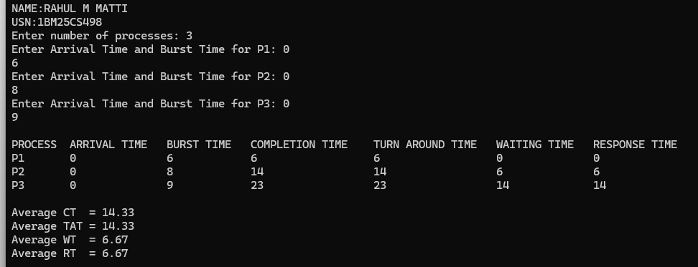
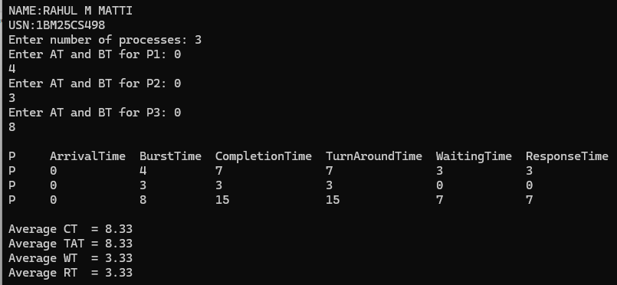
SJF(SHORTEST JOB FIRST)

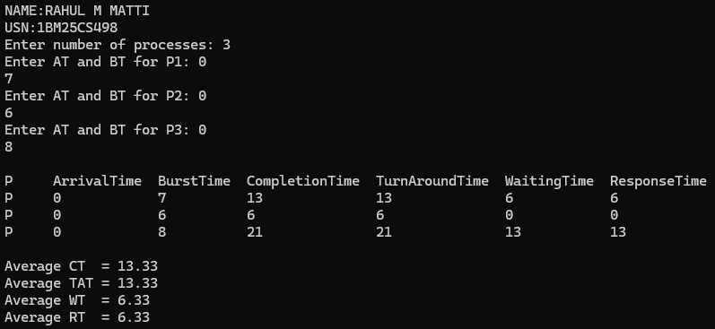
SRTF

